Sorting Out Your Colors
Alex Shvartsman
If you are reading this article, chances are you enjoy drafting and have been playing Invasion Block Limited lately. Think back on your last several matches. How many games were won, or lost, because of mana problems? You or your opponent may have failed to draw enough lands, or lands of the right color.
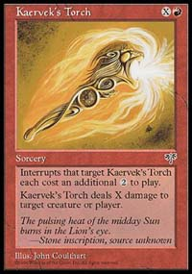
Until recently, working out your mana ratios has not been of such great importance in draft. Modern draft environments (a.k.a. sets designed with Limited play in mind, starting with Mirage) have traditionally discouraged multicolor decks. Mirage block was very tempo-oriented and missing land drops, or being unable to cast your spells right away for any reason, was crippling. Kaervek's Torch and Rock Slide were so powerful though, that players would often splash just a touch of red as a third color to their decks, in order to add these cards. Tempest block saw decks that were even faster, thus allowing a player who got a poor mana draw even less of a possibility to recover. The addition of Shadow creatures made it even more difficult for a slower deck to establish control.
Urza block offered the first glimpse of truly multicolor strategies, culminating with the "Five-Color Green" archetype being one of the most viable draft strategies at Pro Tour-London. Mostly Yavimaya Granger and Yavumaya Elder fueled the deck - solid creatures that allowed a player to access the few off-color lands he added to the deck. The "Five-Color Green" deck was usually base green-red, but would not hesitate to first-pick powerful off-color cards such as Expunge, Sanctum Guardian, Veiled Serpent, or Pendrell Drake. It would then add no more than two or three off-color lands, accessible through multiple Grangers and Elders. The slower overall environment and the cycling ability both helped make this strategy very viable.
Masques block with its searchers was slow enough for decks to splash a third color, but the majority of decks played remained two-color. It was not until Invasion block, and especially the format-shattering Apocalypse that an average player had to learn how to draft and play three, four, or even five-color decks on the regular basis - and it has a lot of players stumped. In this article, I hope to offer a number of tips that will make it a bit easier for you to succeed in drafts.

You will choose the total number of lands based on the average casting cost of your spells and any mana fixers
Figuring out your mana base for a two-color deck is very straightforward. You lay out the cards you've drafted on the table. Eliminate the ones you are definitely not playing, such as off-color cards and late picks. Separate the ones you definitely want to play by color and mana cost. This will let you figure out how many lands you need to play. An average draft deck needs seventeen lands. Sixteen and eighteen are also common, but you will rarely see another number in a solid draft deck. You will choose the total number of lands based on the average casting cost of your spells and any mana fixers (such as Fire Diamond or Llanowar Elves) you might be playing.
The next step is to figure out how many lands of each color you will be playing. The two important statistics are the number of spells in each of your colors, and their casting costs. For example, you might have ten white and seven blue cards - however, many of your blue cards cost 2-3 mana and you have a pair of Counterspells, whereas all your white cards require only one white and several generic mana, and have a converted mana cost of 4-5. In this situation, you will likely be playing nine islands and eight plains. Another factor that should effect both the total number of your lands and the mana ratio are cantrips - spells that allow you to draw a card when they are cast. If you have several inexpensive cards that allow you to draw through your library faster - such as Impulse, Wall of Blossoms, or Zap - you want to be able to cast those cards early in the game. It will increase the probability of you drawing into all of your colors as well as the most powerful cards in your deck.
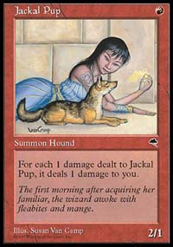
Now suppose that you want to add a very powerful spell of a third color to your deck. First of all, make sure that the card you are adding is a late-game card. You wouldn't want to add a Jackal Pup as the only red card in your deck. Although a Pup is a welcome addition to any red deck, it is a card that isn't very good at all unless you have a chance of casting it early in the game. A direct damage spell like Kaervek's Torch or Ghitu Fire on the other hand gets more powerful later in the game, when you have access to more mana. That is the kind of card you should splash for. When playing a light splash of a third color, it is also very important that you do not try to splash cards that require multiple mana of the color you are splashing. For example, Morphling may be one of the most powerful creatures in the game, but you will not easily be able to splash for it without really weakening the mana support for your main colors.
When choosing whether to splash for a third color in your deck, consider whether the gains outweigh the sacrifices. Are the cards you are splashing for powerful enough to sacrifice mana consistency? In most cases, the splash cards are direct damage or black removal, occasionally a large creature in a deck that is a bit low on men. Even if you do choose to play a third color, keep the splash of it low. In a forty-card deck, you want to make sure there are at least seven mana sources of each of your two main colors. That leaves only three spots for off-color lands. Usually, the following numbers will work out:
# of splash cards # of lands
1-2 2
3-4 3
If your deck did not work out very well, you may be forced to play with five or more cards of a third color. At that point it is hardly a splash, and you better hope that you either drafted some mana fixers, or just get lucky with your draws.
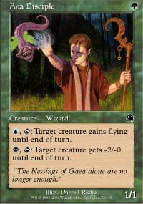
Enter Apocalypse. Suddenly, drafting a straightforward three-color deck (or should I say two colors with a minor splash of a third) becomes very, very difficult. You might start out by drafting red-green with just a splash of black. This should work out fine in the first two packs. Suddenly, Apocalypse will offer you plenty of green-black cards (be they gold, or cards like Ana Disciple that are made viable by the off-color ability) but very few solid cards that are red or green but do not require other colors to be useful.
Whereas you had maybe 15-17 playable cards by the end of the second pack and only two of them were black, your end result may be something like 24-25 playable cards, with a pretty even split between the three colors. Even if you draft perfectly, this situation will happen often when drafting this block. However, you can improve your draft and your mana base with some careful planning.
The first rule of Invasion block draft is that mana-fixers are incredibly important. Pick up tap-lands (such as Coastal Tower) and Lairs (such as Dromar's Cavern) very early. I've occasionally picked Lairs as early as 2nd pick of pack 2, when I felt my deck was going to need it. On average, I think both land types should go around fifth pick - earlier than they would have before Apocalypse. Even a single land that gives you access to multiple colors of mana does wonders for the overall mana ratio, offering you more flexibility and decreasing the chances of mana problems. "Sac lands" such as Irrigation Ditch are worth picking up late in a draft. One or two of them might make it into your deck, though it is inadvisable to play too many lands that come into play tapped.
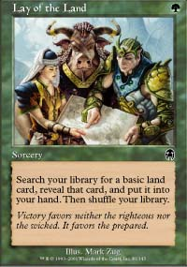
Green mages have it a little easier. There are a number of cards that allow you to smooth out your mana base. I will only draft four or five-color decks if I have green as my base color. Some of the best mana fixers in green are Harrow, Nomadic Elf, Quirion Elves, Lay of the Land. If these aren't available, there are a number of viable alternatives such as Quirion Explorers and Primal Growth. Playing with such cards allows you to do what you would in Urza block - pick out some very powerful splash cards from other colors and play them using very few lands that produce that color of mana. For example, your green-white-blue deck can play one Magma Burst and one Agonizing Demise off a single Swamp and a single Mountain, provided you also have a Harrow and a pair of Nomadic Elf. The case is somewhat extreme, but you might have also picked up other cards that will help you - Darigaaz's Caldera counts as a source of green mana but also produces your off-colors in the bargain. Quirion Sentinel is a 2/1 creature for 2 mana (already good), but it can also give you a one-shot access to any color of mana you might need at the time.
The second best color when it comes to the mana fixers is blue. Although it does not offer mana acceleration the way green does, blue has a common creature in each of the three sets that provides you constant access to any color of mana. The triumvirate of Dream Thrush, Sea Snidd, and Reef Shaman tap to change a land into any basic land type. This can be useful to mana-hose your opponent as well as solve your own mana problems. More importantly though, it gives you the flexibility to splash some off-color cards even if you are not playing green.
Black has no mana fixers to speak of, but it yields a number of solid common picks in Apocalypse that require no off-color mana - such as Phyrexian Rager and Zombie Boa. White is pretty much in the same boat with its common Flagbearers, but it also gets Helionaut - a mediocre card, but one that you can use to help fix your mana if you really have to. Red has no redeeming qualities when it comes to producing or altering mana.
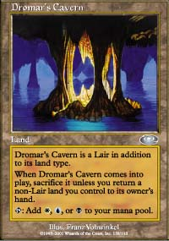
A good drafter knows that the process of drafting is not about picking the best card - or even the best card in your color - out of each pack. It is about picking the card you need most, building your deck as you go along. Same is true with developing your mana base. When drafting, you must keep in mind the approximate casting costs and color requirements of your spells. That way you will know whether you have to pick that Dromar's Cavern early on - or can afford to pass it up and pick up another powerful card in your colors.
There are also several basic paths to follow when you are drafting your deck. None of them are better or more viable than others - you should simply choose one based on the cards available to you over the course of the first few packs.
1) Draft a "Lair" color combination - as in three colors located next to each other, such as black-red-green. This will give you access to more gold cards in the first two sets and let you take full advantage of Lairs and sac lands, but will provide only a single color combination to draft in Apocalypse (such as black-green).

2) Draft two colors and their enemy. Pick a "friendly" two-color combination such as red-green and draft the opposite of both colors (in this case, it would be blue). You may miss out on some gold cards in the first two sets, though not many - you've still got your Yavimaya Barbarians and Hunting Kavu - but it will pay off big time in Apocalypse, where you will have access to both red-blue and green-blue cards.
3) Draft opposite colors from the start. A color combination such as red-blue can be perfectly viable from the beginning. You can still pick up powerful gold cards that come along and keep the other color as a splash (red-blue could use a Terminate and Blazing Specter as its black splash). This strategy is somewhat dangerous - since very few people pursue it, you will almost certainly end up fighting for one of your two main colors with your neighbor to the right. If it works out though, you will have a two-color deck or only a small splash of a third color, building a near-perfect mana base.
4) Draft a 4-5 color deck. Pick mana fixers such as Harrow and Nomadic Elf very early on, sacrificing some of the more powerful cards available in the same packs. Gain the benefit of being able to draft almost any of the more powerful cards in Planeshift and Apocalypse though.
It is very difficult to learn much about Limited play by reading an article. There are too many variables, and each deck's mana requirements are unique in some way. I've kept this essay very generic to make sure that what I wrote would apply in most cases. However, do not take it for granted - analyze each card pool you end up with, experiment with various mana configurations, and solicit the advice of the better players at your store. It is only through practice that your game will truly improve.

